**Project name: Healthfirst Care initiative**

**Data Analysis Report**

**Introduction**

This report presents the findings from the analysis of patient appointment data, feedback (satisfaction) data, and resource usage data for **HealthFirst Care**. The objective of this analysis is to identify operational inefficiencies, trends, and areas for improvement in scheduling, patient satisfaction, and resource utilization, enabling better decision-making and enhancing patient experiences.

**Data Cleaning Summary**

* **Duplicates Removed** from all datasets (appointments, feedback, resources).
* **Date/Time Standardized** to MM/DD/YYYY and HH:MM AM/PM formats.
* **Missing Feedback Scores** replaced with the average (6.27).
* **Missing Non-Numeric Values** filled with “N/A”.

**Key Findings**

**1. Appointment Data Insights**

* **Top Departments (by Appointments):**
  + Cardiology (37)
  + Pediatric (35)
  + Neurology (30)
* **Least Appointments:**
  + General Medicine (24)
* **Busiest Appointment Time:**
  + 6:00 PM (15 appointments)
  + Also busy at 11:00 AM & 12:00 PM
* **Slow Hours:**
  + 1:00 PM – 2:00 PM
* **Seasonal/Peak Trends:**
  + Spikes observed in April & September (possible health drives or seasonal trends)

**2. Feedback/Satisfaction Data Insights**

* **Highest Satisfaction (High/Low):**
  + Neurology (33/1)
  + Pediatric (32/5)
  + Cardiology (31/2)
* **Lowest Satisfaction Ratio:**
  + Orthopedics (21 High / 8 Low)
* **Overall Feedback:**
  + 164 High vs 27 Low → Generally positive feedback
* **Observation:**
  + Neurology shows **excellent patient satisfaction**

**3. Resource Usage Data Insights**

* **Top Resource Usage (Average Hours):**
  + Pediatric (4.85 hrs)
  + Cardiology (4.29 hrs)
* **Lowest Resource Usage (Average Hours):**
  + General Medicine (3.41 hrs)
  + Oncology (3.47 hrs)
* **Alignment with Demand:**
  + Higher resource usage aligns with departments having

higher patient volume.

**Overall Summary & Recommendations**

* **Pediatric & Cardiology →** High usage, satisfaction, and demand → **Maintain & plan for scalability**
* **Neurology →** Moderate volume, best satisfaction → **Benchmark for improving other departments**
* **Orthopedics & General Medicine →** Moderate volume, lower satisfaction → **Requires further analysis & improvement**
* **Peak Appointment Time →** 6:00 PM → **Allocate more staff/resources during peak hours**
* **Seasonal Trends →** April & September → **Pre-plan staffing and resource availability accordingly**

**Pivot Tables-**

**Appointment Table-**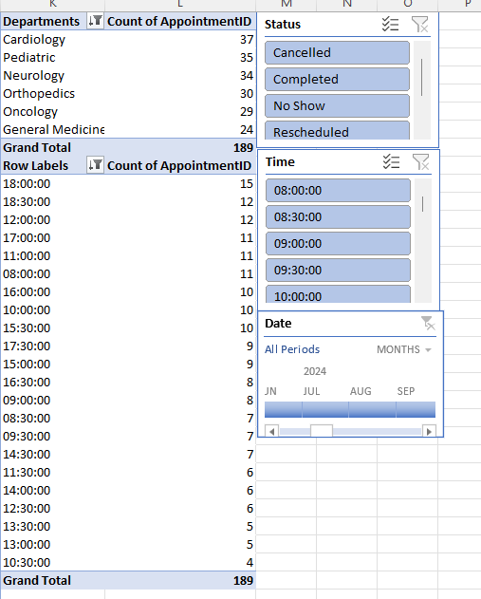

**Feedback Table-**

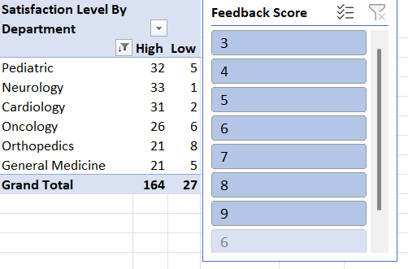

**Resource Table-**

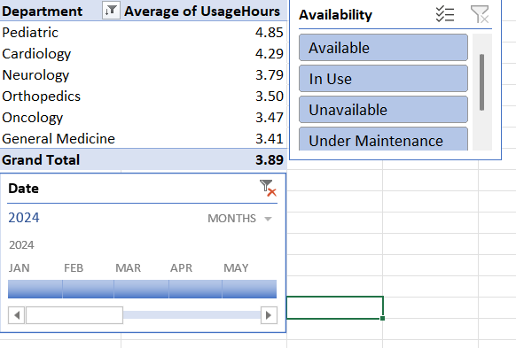

**Charts & Graphs.**

**Appointment Table-**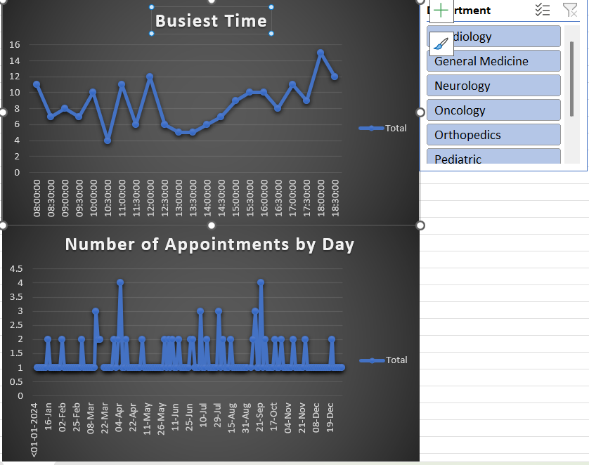

**Feedback Table-**

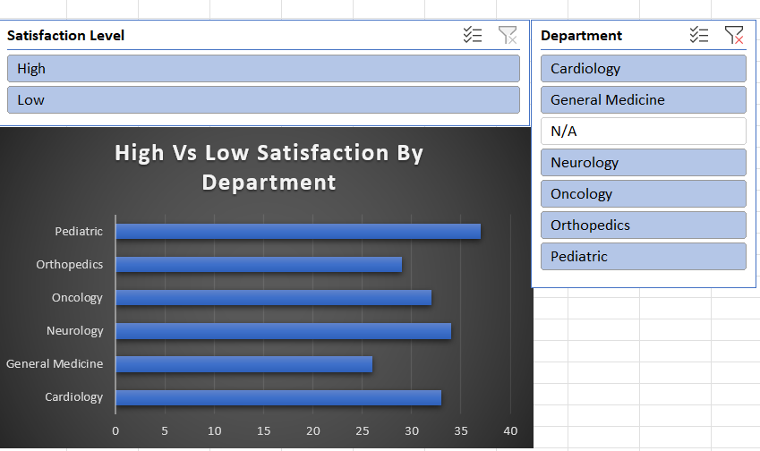

**Resource Table-**

